Nathan Fisher

Michael Gephart

Nick Hilbert

Ian Ruedinger

COSC 3810 3B Weather Station System Report

## User Stories

**User Story #1: Tracking Precipitation with the Data Management & Archives System**

* Sunny is a meteorologist whose job is to accurately report the monthly rainfall and snowfall totals to her country's government.​
* To complete this task Sunny must login to the National Weather Service Data Management and Archiving System using specific credentials that give her privileged access.​
* Once logged in, Sunny is presented with a main menu that has options to 'view archives', or 'generate summary'.​
* If Sunny selects 'view archives', the system will direct her to a table where weather information about each of the country's weather stations is stored. The system allows Sunny to view but not edit the data that is listed.​
* If Sunny selects 'generate summary', the system will allow her to select certain weather variables over a time frame, and a chosen aggregation (MIN, MAX, SUM, etc.) from drop-down menus. Once Sunny is ready to confirm her choices, she selects 'run' and the system will calculate the aggregation of the selected variables over the selected time frame. ​
* After this calculation is complete, the system will show the calculation results to Sunny as well as options to 'print summary' or 'edit'. If she clicks 'print summary' the calculation results will be printed, and the system will then direct Sunny back to the main menu. If she clicks 'edit' then the system will go back to the previous screen and allow Sunny to reselect variables. ​

**User Story #2: Maintenance of Systems**

* Adam is one of the lead technicians for the National Weather Service who monitors all the weather stations within his operational region.​
* At the start of each shift, Adam signs into the NWS Station Maintenance System using his credentials.​
* The status of all stations within the region is loaded onto a table for Adam, which displays the battery status (depleted, charging, etc.), weather alerts, system failures, and address/GPS coordinates. Stations that are currently experiencing power or equipment failure will be sorted to the top of the table, along with their respective error codes.​
* If Adam and his team conclude that the issue cannot be resolved remotely, a technician will be assigned by Adam to repair the issue on-site, using the system's roster and ticket system.​
* Adam can click on the Create ticket button on the sidebar of the program to open the ticket menu, where Adam can input the assigned technician, station ID, failure description, and required replacement parts. ​

**User Story #3: Guest / Visitor Data Viewing**

* Troy is a resident of Greenwood, a town with a weather station. He is a new user of the National Weather Service. He first enters his credentials that will be stored in the database for later.​
* Troy is then met with a terminal prompt asking him to type in the location in which he intends to view weather data. If he types in a town without a weather station, he receives an error message and is asked to try again. Troy typed in his town name "*Greenwood*."​
* Troy is presented with a terminal where he may select different data sets such as **precipitation**, **wind speed,** direction, **temperature**, etc. When he selects an option, the appropriate table is displayed with his location and weather data. These are the only things that can be selected on this screen for viewers like Troy.

## Software Requirement Specification

* The service must provide the most up-to-date information to all users and admins.
* Multiple remote weather stations across the country must be managed, including maintenance, repair, and software updates from a central location/office.
* The program will regularly generate (obtain) weather data and create weather maps.
* Data retrieved from the weather monitoring stations will then be archived into a database, allowing historical weather access.
* The weather stations send summaries of the weather data that has been collected from the instruments (e.g. anemometer, barometer, ground thermometer) in the collection.
* Weather stations are usually asked to report once per hour but this frequency may differ from one station to another and be modified in the future.

## Design Document

User Story 1 Diagram:

Use Case Diagram

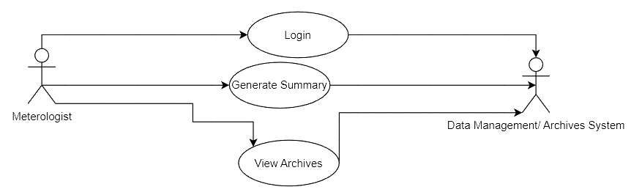

Sequence Diagram for Viewing Data:

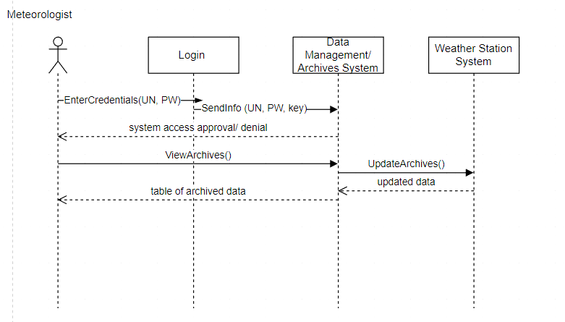

Sequence Diagram for Generating Report:

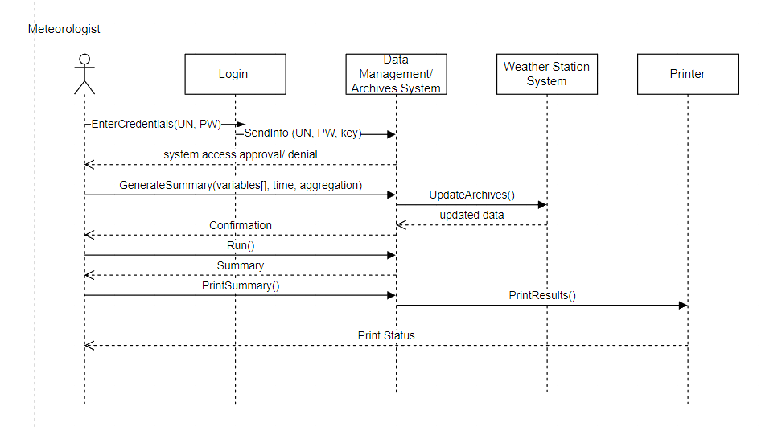

Class Diagrams:

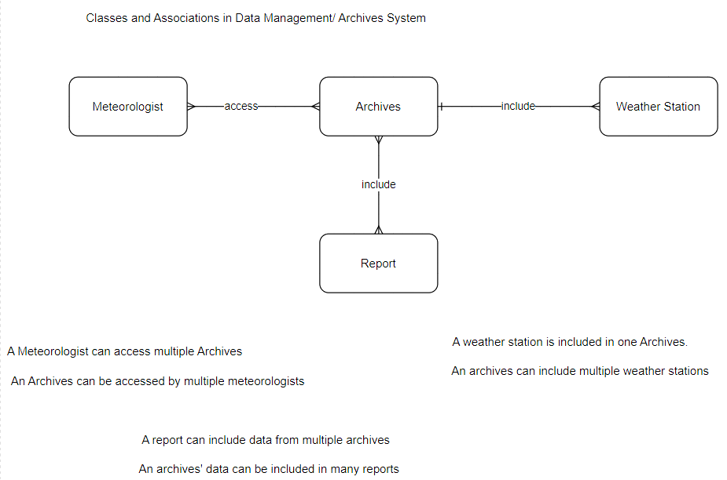

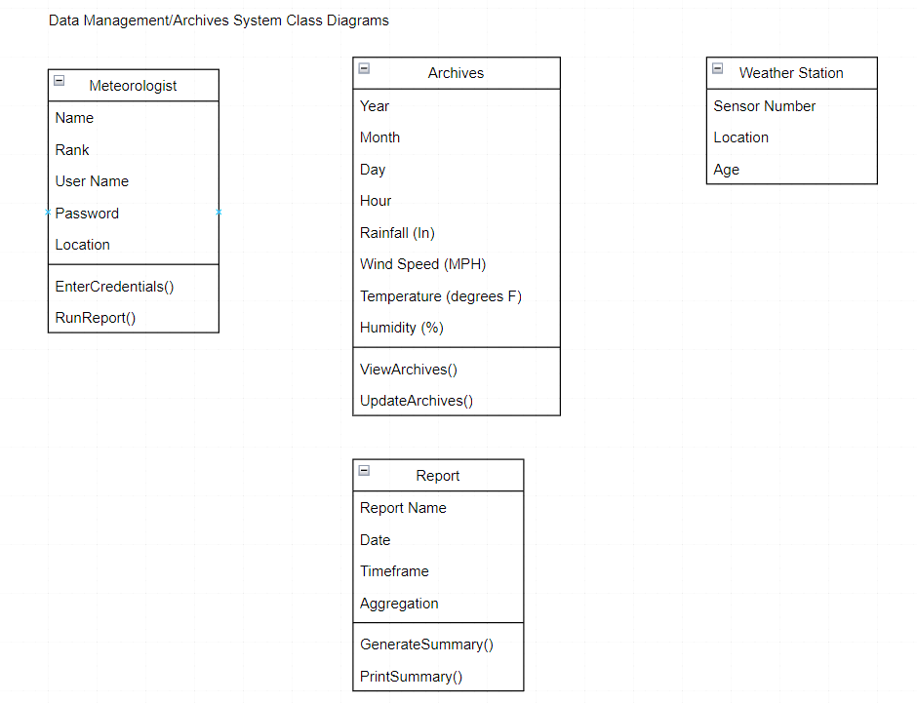

User Story 2 Diagrams:

Use Case Diagram:

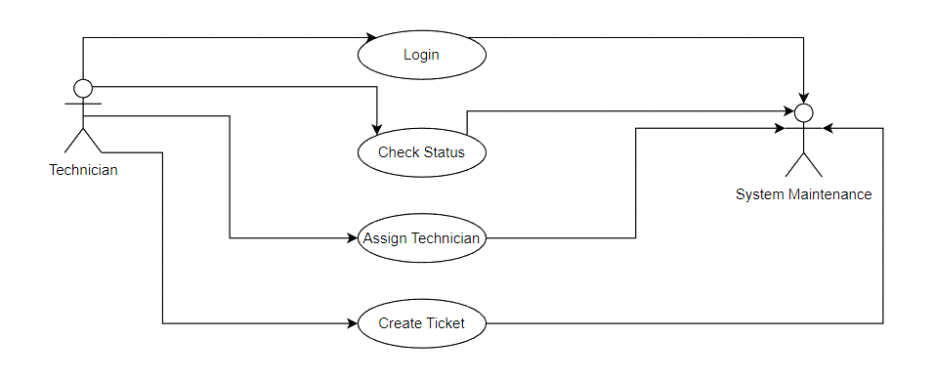

Sequence Diagram:

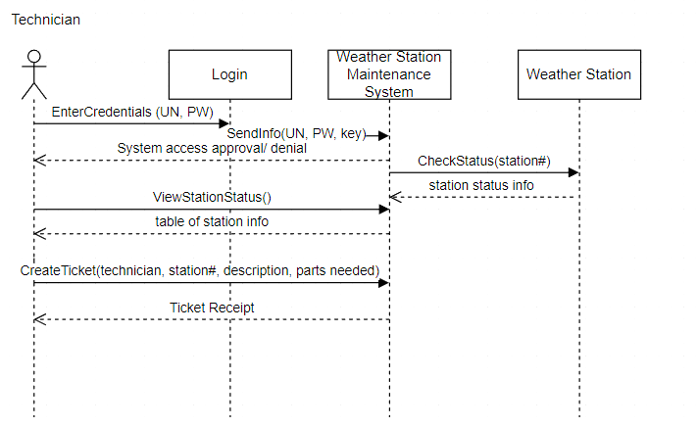

Class Diagrams:

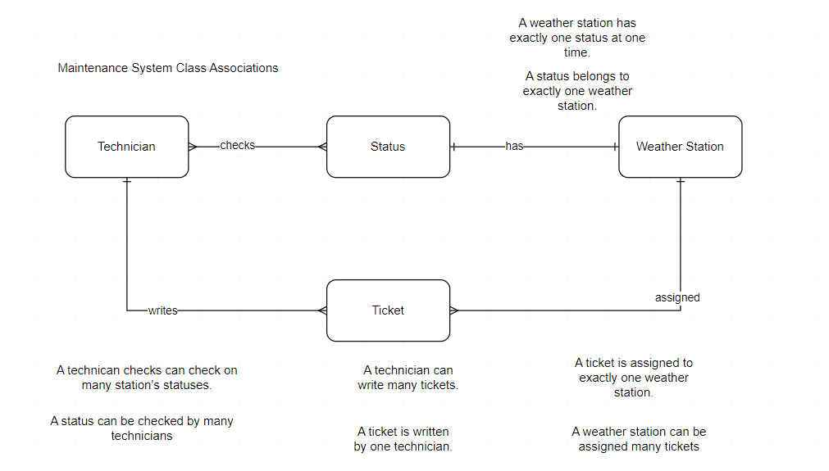

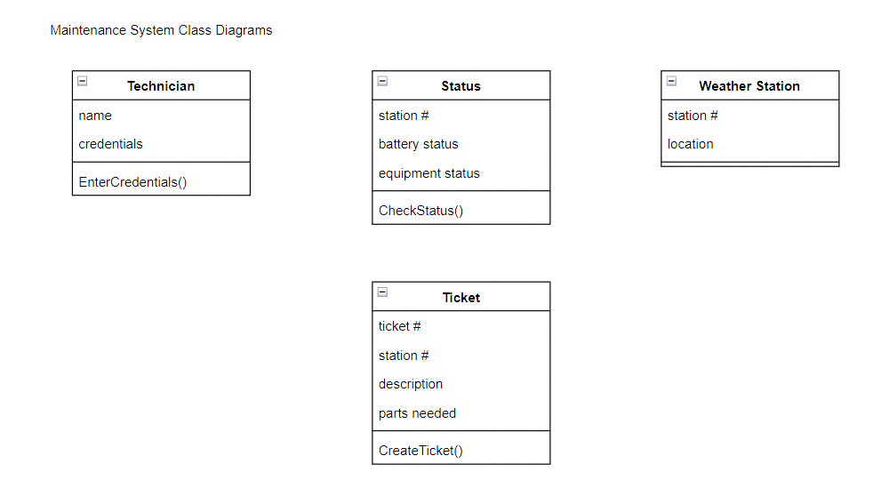

User Story 3 Diagrams:

Use Case Diagram:

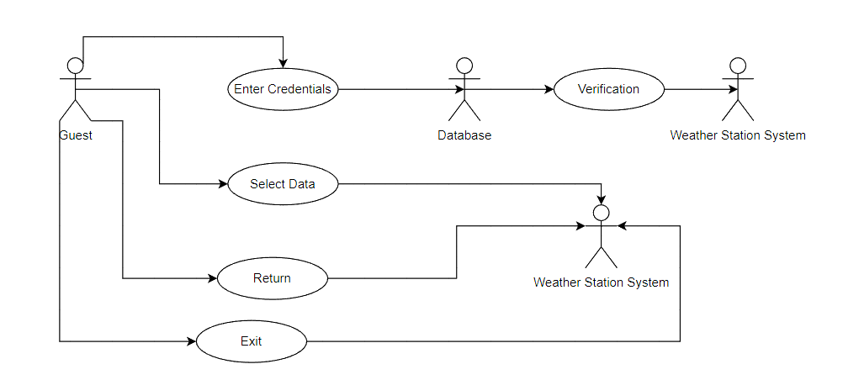

Sequence Diagram:

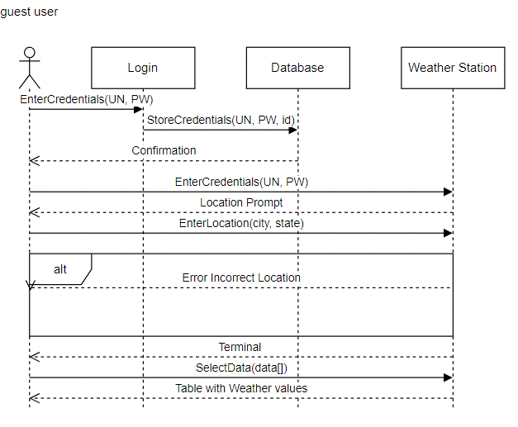

Class Diagrams:

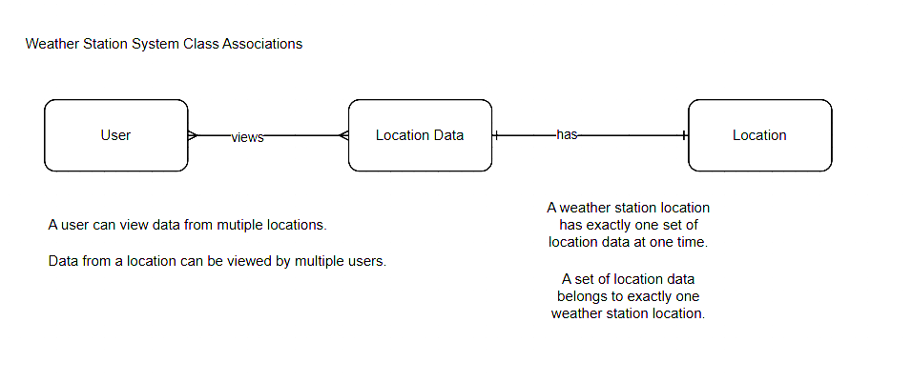

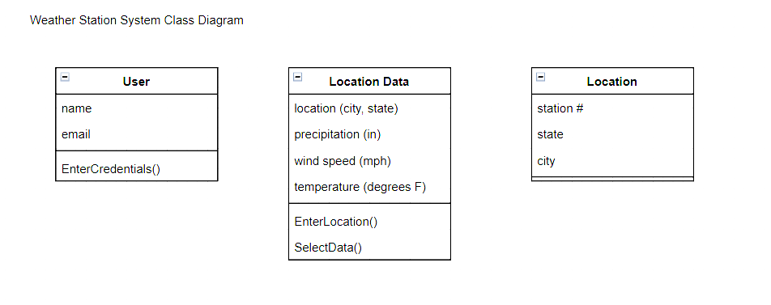

## User Story Acceptance Tests

Acceptance Criteria

1. Data Management/ Archives System

* Users can login, view archives, and generate summary reports

1. Maintenance System

* Technicians can login, view station status, and create tickets

1. Weather Station System

* Guests can enter a location, and filter and view weather data

## Code

<https://github.com/mgephart2/cosc3810/blob/main/Final_Project>

## Deployment Plan

1. Define the hardware and software requirements:

### Determine the required hardware, such as servers, sensors, and networking equipment.

1. Install and configure the hardware and software:

### Install the necessary hardware components and ensure they are properly connected and configured.

1. Deploy the sensors:

### Install weather sensors in appropriate locations, such as on rooftops or poles, to gather data on temperature, humidity, wind speed, and other relevant weather parameters.

### Ensure that the sensors are properly calibrated and tested.

1. Connect the sensors to the system:

### Configure the sensors to communicate with the weather monitoring system.

### Ensure that the sensors are transmitting data correctly and that the system is receiving the data.

1. Collect and store data:

### Set up a database to store the collected weather data.

### Configure the system to automatically collect and store data at regular intervals.

1. Monitor and maintain the system:

### Monitor the system to ensure that it is functioning properly and that data is being collected accurately.

### Schedule regular maintenance and updates to the hardware and software to keep the system up-to-date and functioning efficiently.

## Demo Video

<https://www.youtube.com/watch?v=LsRkzDQQPJw>